**IAM TASK**

1. Create one IAM user and assign ec2, s3 full access role.

AWS console >> IAM >> Users >> Create user >> Name >> Choose whether to provide access to the AWS Management Console >>Next >> Set permissions >> Attach policies directly >> select ec2 full access and s3 full access >> Next >> Create user >> Download credentials

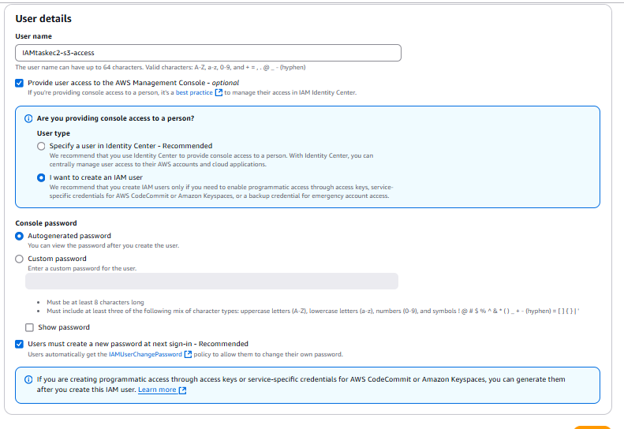

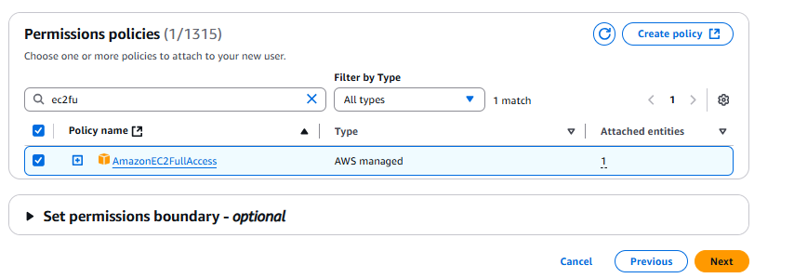

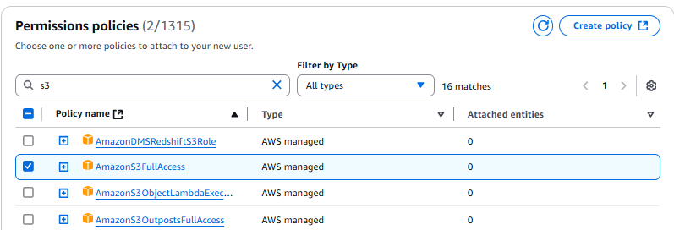

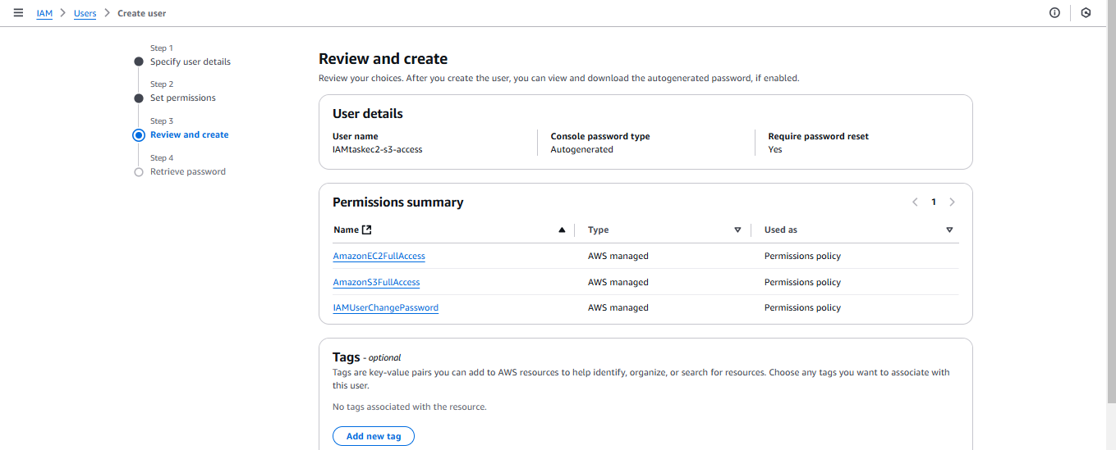

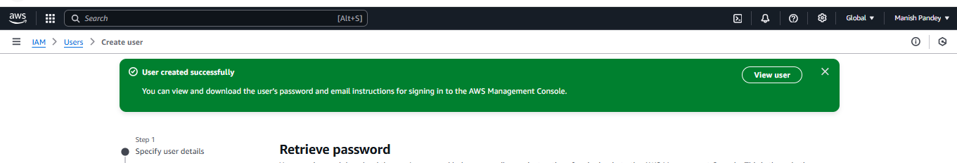

Logged in using IAM user credentials.

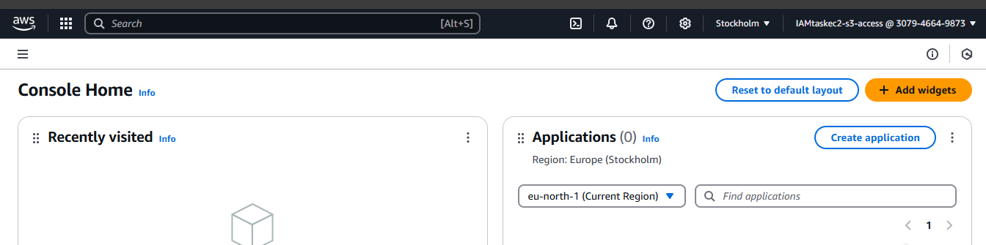

Accessing ec2 and s3 using IAM user credentials.

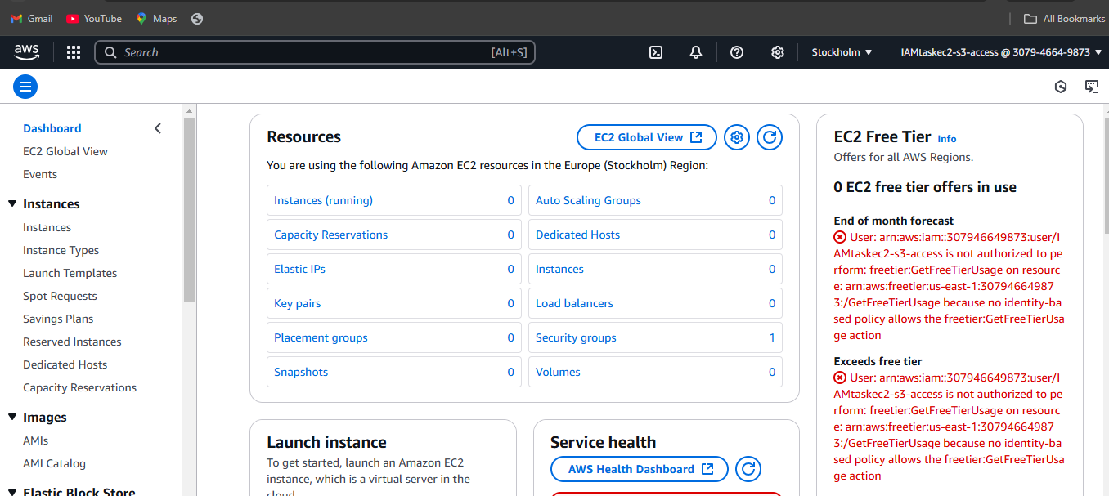

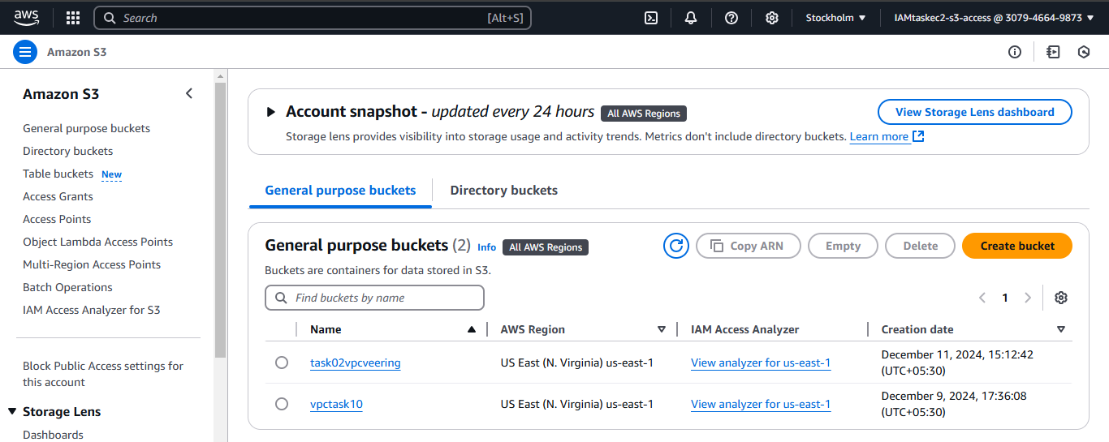

1. Create one Group in IAM and Assign Read access for ec2.

AWS console >> IAM >> User groups >> Create group >> Name >> Add users if needed >> Attach permissions policies >> Search “AmazonEC2ReadOnlyAccess” >> Select >> Create user group

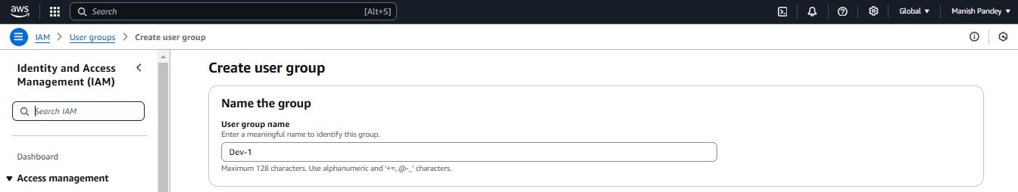

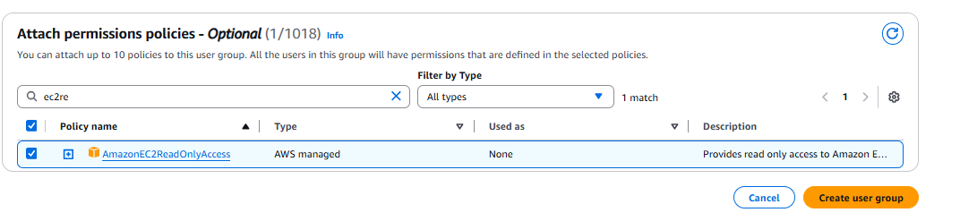

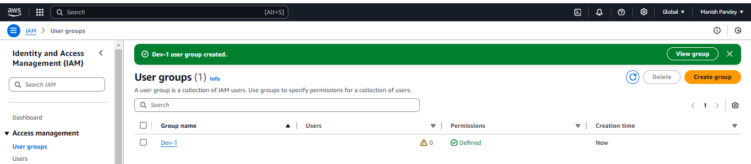

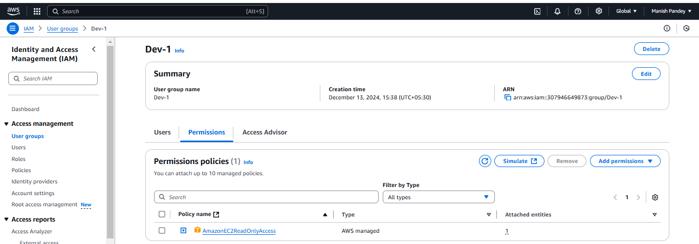

1. Create a new user with name Devops and add to the group created in task2.

Created user “Devops” following the steps in task-1.

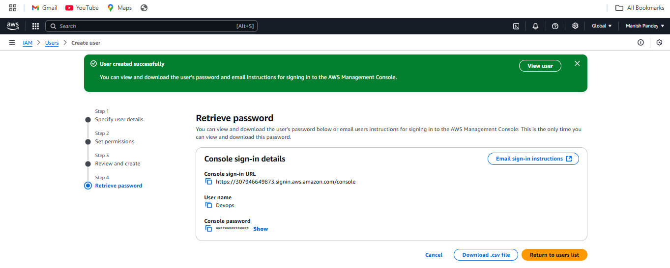

User groups >> Select the group >> Add users >> Select user >> Add users

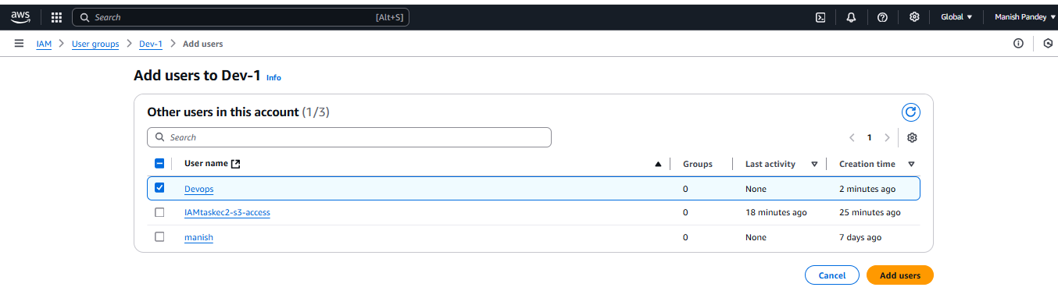

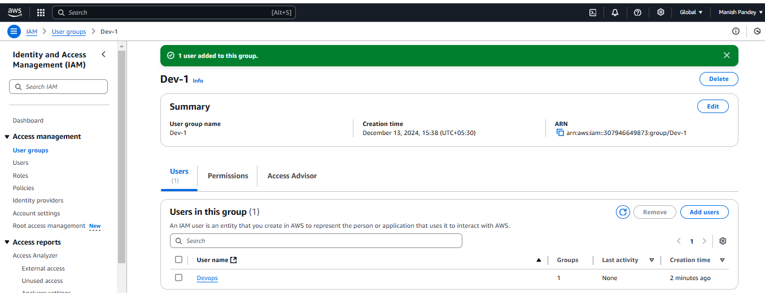

Logged in using Devops – user credentials to check AmazonEC2ReadOnlyAccess.

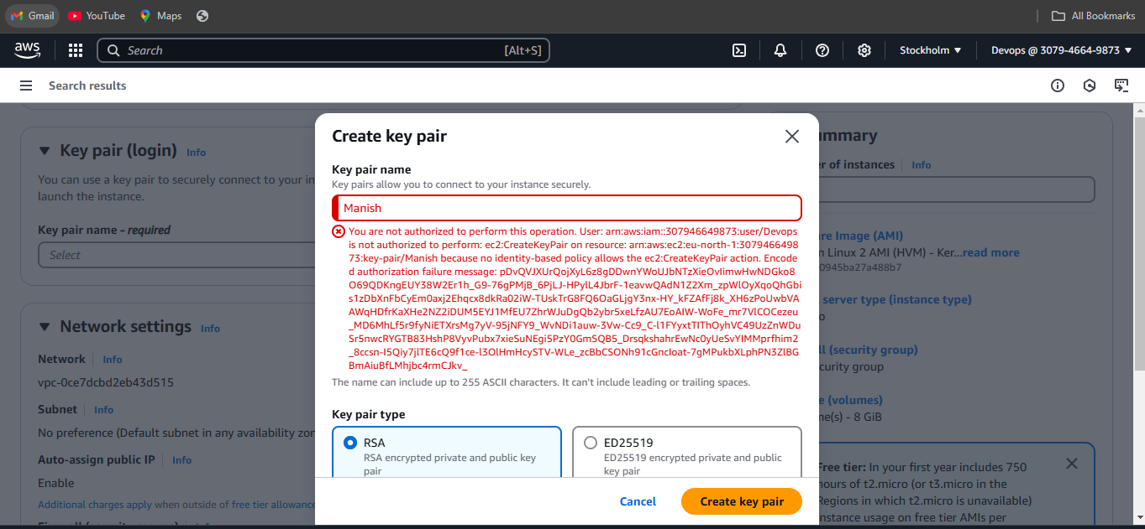

1. Write a bash script to create a IAM user with VPC full access.

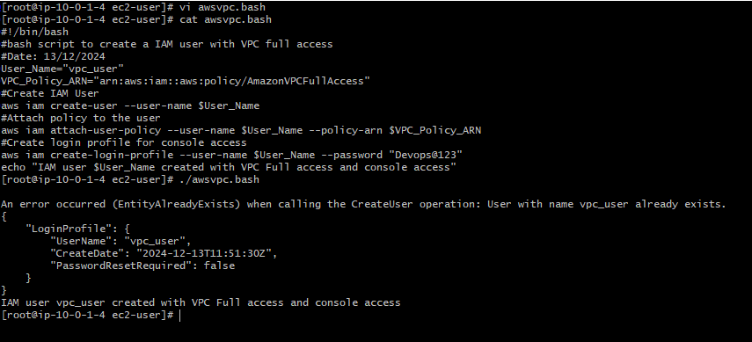

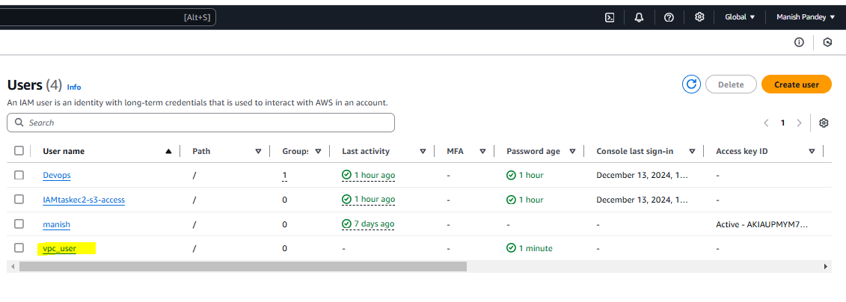

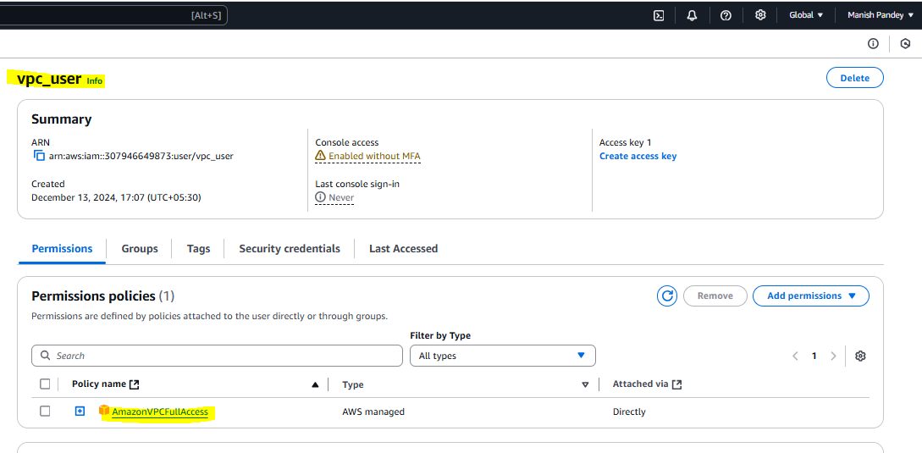

1. Create an IAM Policy to access ec2 for a specific user in specific regions only.

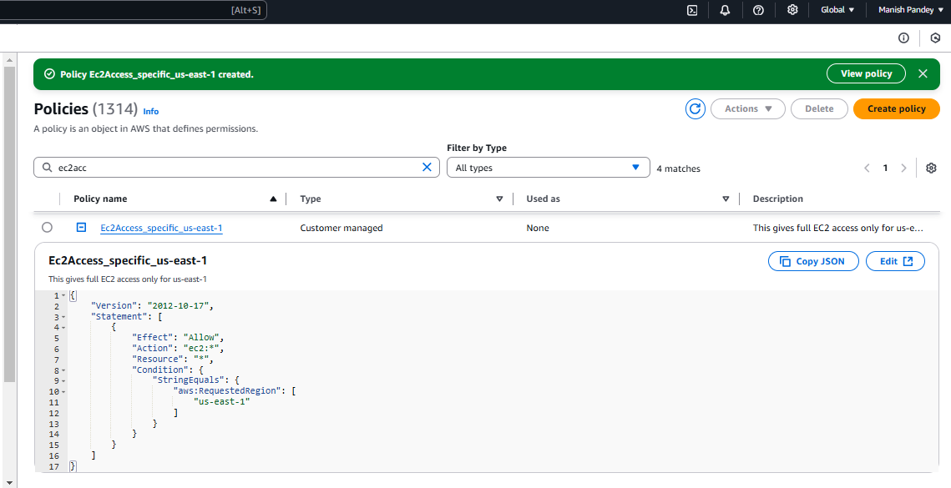

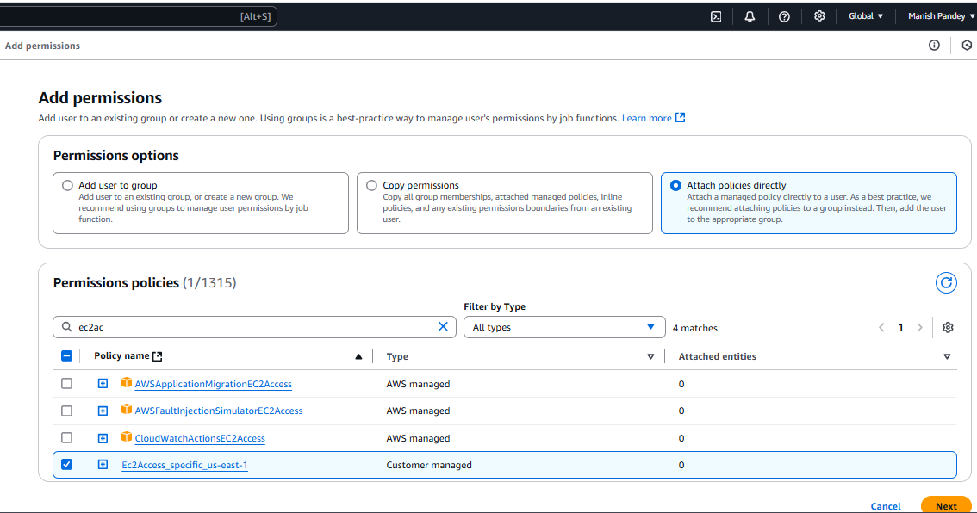

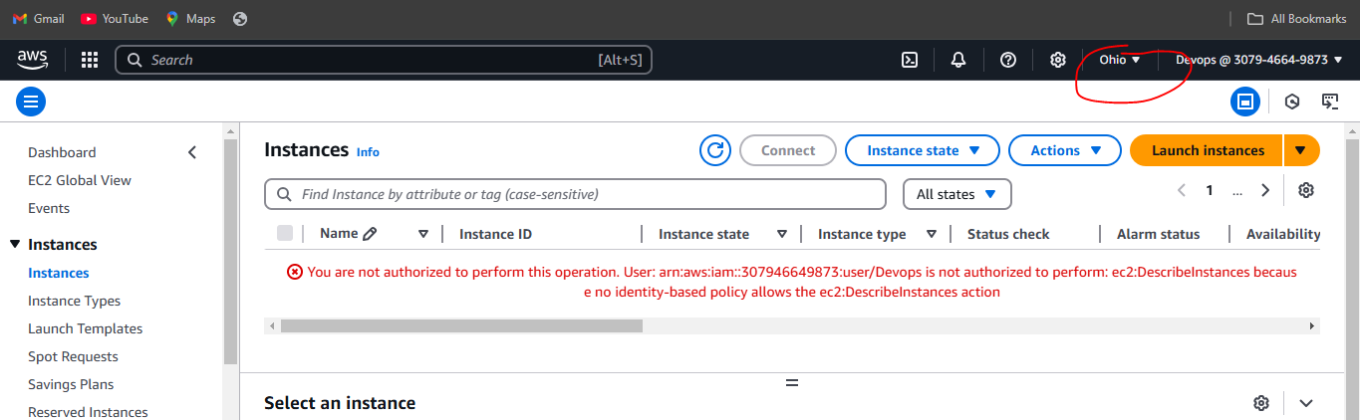

We have two accounts Account A and Account B, Account A user should access s3 bucket in Account B.